Need a Little Cheese With That Wine?: How To Make The Most Of Your Wine Festival Experience
By Megan Delaney

The poet and author, Robert Louis Stevenson said, “Wine is bottled poetry “. If this is true, than the life of a wine enthusiast must be the largest work of poetry ever.

Chapter 1

Reds - Pinot Noir, Merlot, Shiraz, Malbec, Cabernet Sauvignon.

Chapter 2

Whites – Chardonnay, Sauvignon Blanc, Semillon, Moscato, Pinot Grigio, Gewürztraminer, Riesling.

Chapter 3

Sparkling Wines.

Regardless of whether you’re a wine connoisseur or just entering the scene, a wine festival is a great way to expand your knowledge of wines. It’s fun to learn about the grapes from which wines are created, what regions certain wines come from, and even learn a little about the process of making wines.

The following information may come in handy as you sample your way from one vendor to another… and another. This simple guide covers everything from how to pace yourself and not overdo it, to how to transport the bottles of wine you purchase. You’ll find useful tips that will ensure you come away with the most memorable experiences. In addition, maybe you can even write your own book of wine-inspired poetry.

Plan Your Day and Broaden Your Horizons
Grabbing a map of vendors, and where they’re set up at the festival is an excellent way to start your day. Alternatively, if you can get online before the event, you may be able to see which vendors are participating, and where you want to start. Why not use this year’s festival to try all new wines to add to your favorites, and skip the ones you already know? Make the most of your time, and experience this year’s new varieties.
Pace Yourself
Regardless of how ambitious your tasting ‘to-do’ list is, consider setting a timer in order to take a break from wine sampling and drink some water. That’s also a good time to break into your picnic basket or stop off at a food vendor to grab a snack. Taking advantage of the live music that is usually present at wine festivals is a great break from sampling too. Pace yourself so you can enjoy your day. Drinking too much too quick may result in a less than pleasant experience.

Learn What You Can
Sampling is not the only way to learn about new wines. Though tasting is most of the fun, it’s also a great idea to ask questions as the samples are being poured. Talk to the vendors. Ask questions to get to know more about the wines you’re sampling and about wine in general. Examples of questions you might ask are:
- Does it matter what glass I use when pouring red versus white wines, or different wines of the same color?
- Is decanting really necessary and what does it do to improve the taste of wine?
- Do all wines have sulfites?
- What are your most popular wines?
- Is Champagne the same as sparkling wine?
Questions and answers about wine are available online. You can make your own list or get some hints from researching before you go.
Sample in Style
At a wine festival, you’re likely to want to purchase a bottle – maybe two. You’re going to want a convenient way to carry that. Some wine bags are insulated to keep wines chilled. This roomy picnic backpack, from uncommongoods.com, is a great way to transport one bottle of wine for picnicking, as well as any snacks you may want to insulate. It even comes with picnic essentials like wine cups, utensils, plates and a wine key.
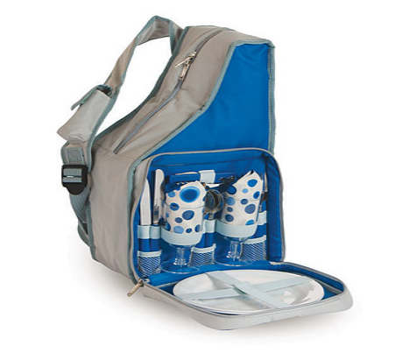
For the more adventurous picnicker, and if you’re enjoying the day with a group of friends, this wineenthusiast.com wine picnic backpack for 4, includes everything you need for an enjoyable day of wine sampling with friends. It includes a comfy, waterproof, fleece picnic blanket, a wooden cheese board, a stainless steel cheese knife, salt and pepper shakers, all the plate ware, glasses and utensils you need, as well as two insulated bottle holders and a corkscrew.
Don’t Let Sour Grapes Ruin Your Day
Lastly, know ahead of time that you’re most likely going to run into a few ‘over indulgers’, who can’t help but bump into you with your full glass of wine. Don’t let them ruin your day! You may very well encounter some unsavory situations at a large public event like this. Even mother nature can put a damper on things, if you’re not prepared for anything but the quintessential wine tasting day. Keep yourself focused on your good time and be prepared. Of course, it never hurts to wear darker colors, bring some wet naps, carry a stain stick and bring a rain poncho!
For a great list of food and wine events, visit: http://www.localwineevents.com/festivals. Write in and share your stories with us.
Until then, CHEERS!

